# WEEKLY REPORT

Summer Internship 2024

Student Name: Dhvani Patel Roll No: 21IT108 Week No: _____3______ Duration: __**27/05/2024**__ :____**01/06/2024**____

Company Name: Agevole Innovation Private Limited

Project Name: Agevole Cloud

**Summary of Work done the week (Attach supporting Documents):**

* **Jenkins Fundamentals:** Gained a solid understanding of Jenkins as a continuous integration (CI) server. Explored its role in automating software delivery pipelines.
* **Configuration and Management:** Learned to set up and configure Jenkins projects, including defining build steps and integrating with source control systems.
* **Pipeline Automation:** Experimented with creating automated pipelines using Jenkins, potentially including tasks like building, testing, and deploying applications.

**Plans for next week:**

* Exploring Wordpress.
* Deployment of Wordpress Website

## References:

<https://www.jenkins.io/>

**Name & Signature**

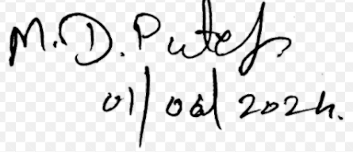

## External Guide Internal Guide